**GUIDE TO SETUP THE SYSTEM**

1. **Connecting the battery**

The MKR 1010 battery connector terminal is inverted. So, you have to reverse it otherwise it will not work when connected normally. So connect it as shown on the diagram below.

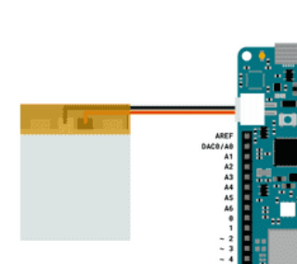

1. **Installing libraries and boards**

Install the following libraries in Arduino IDE sing Library manager; **Tools >Manage Libraries**

* CayenneMQTT by myDevices
* WiFi101 by Arduino

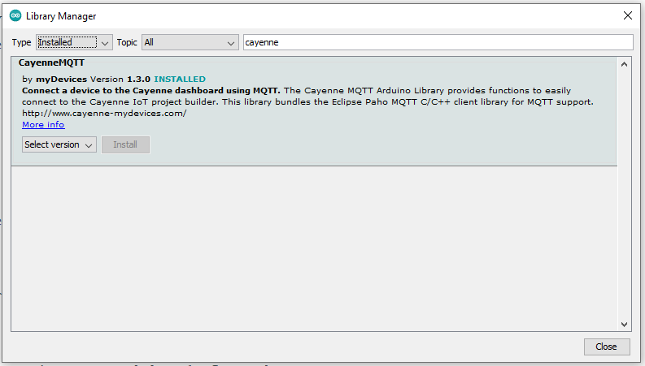

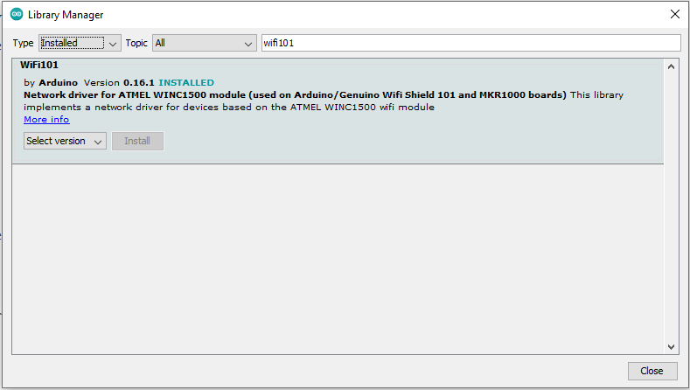

Install the MKR WiFi 1010 board if not installed using Board manager

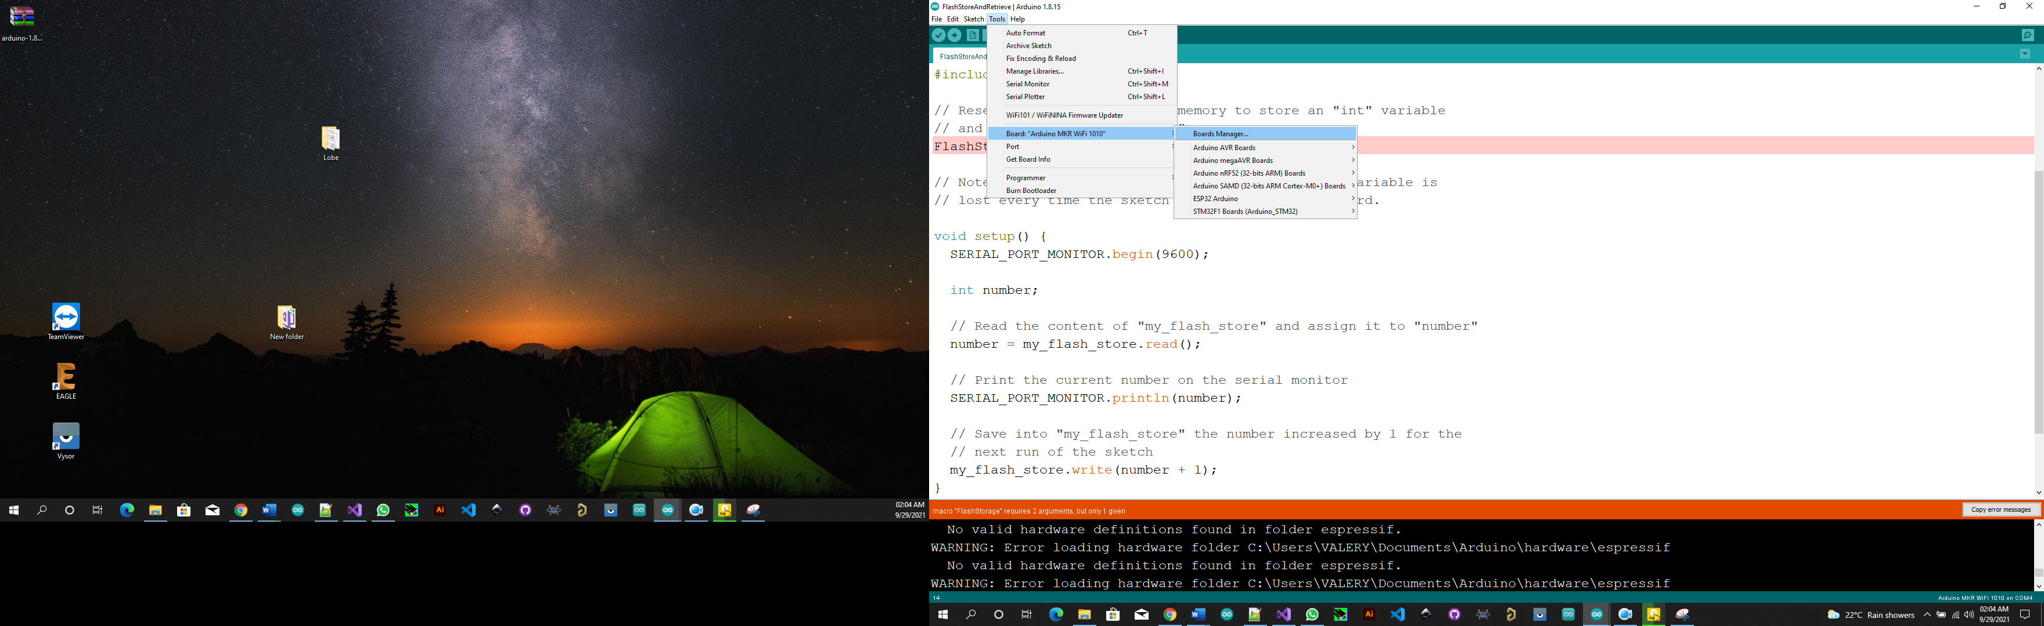

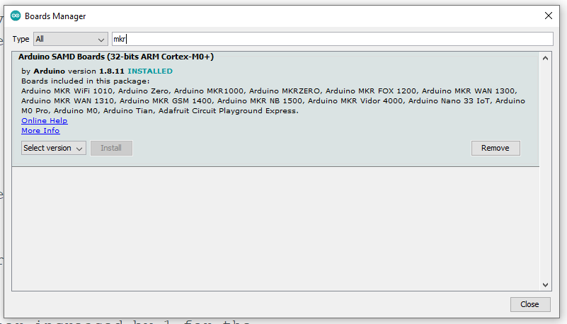

1. **Configuring Wi-Fi and Cayenne in Arduino**

* WiFi: change "ssid"to your WiFi name and "wifiPassword" to your wifi password

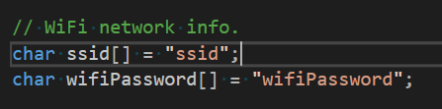

* Cayenne:

Login to Cayenne platform. Click on *Bring Your Own Thing*.

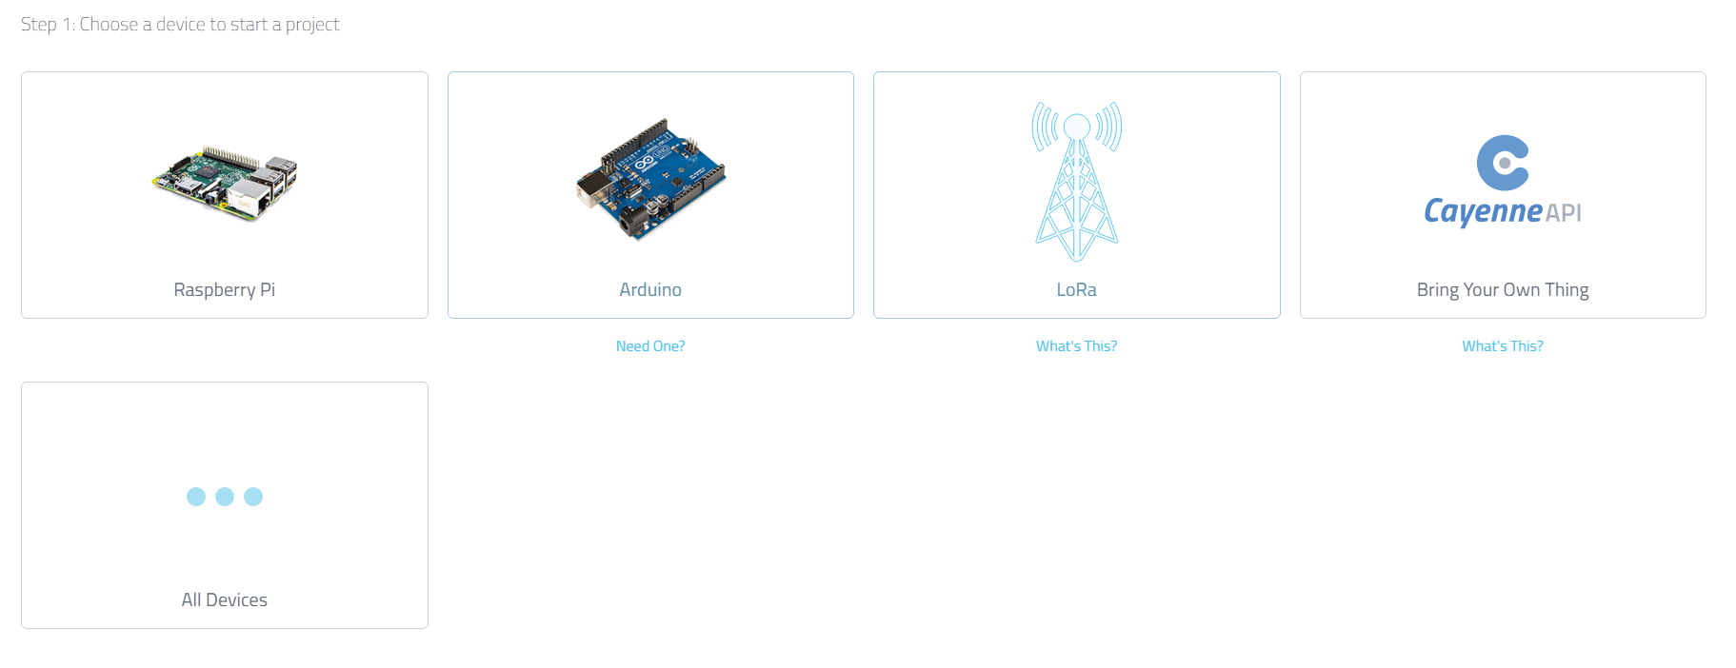



* Give a Name to your device in 4



* Copy 1, 2, and 3 to Cayenne credentials in arduino code

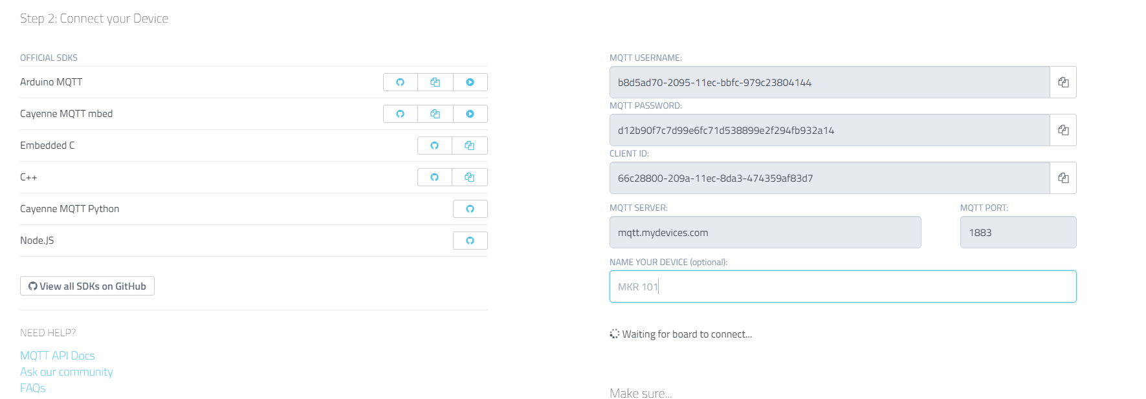



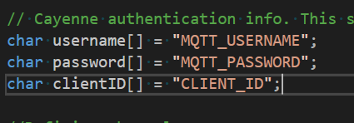



* Don’t close the page
* Compile and upload code to Arduino. Make sure your wifi server is ON.
* Three Widgets will be created in Cayenne.

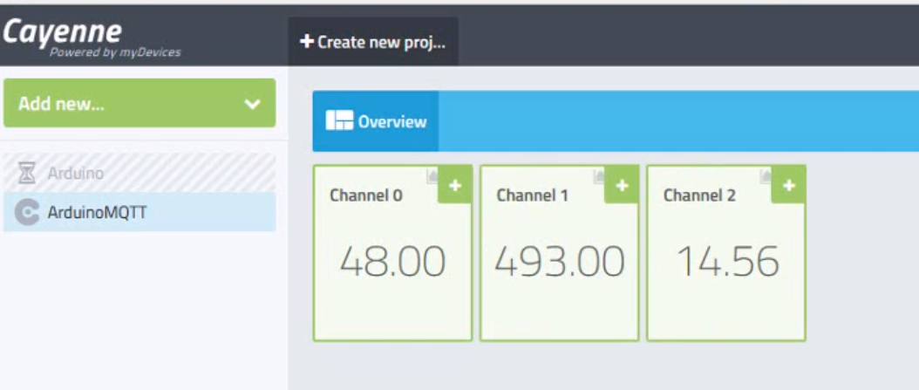



* Click on the plus “+” sign to add the Widgets to your dashboard.



* Then click on the setting icon to rename the Widgets to whatever you want, and also choose icons for the widgets

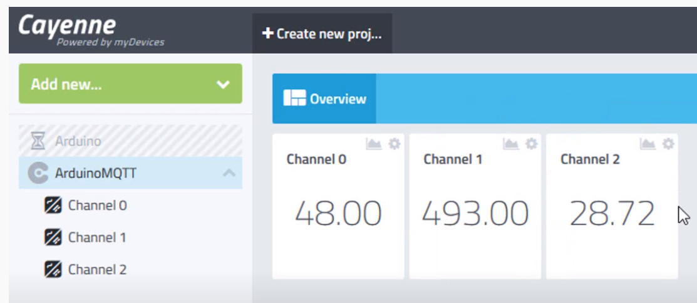



1. Watch the short video I will send to complete Cayenne setup.